BIT4138: Advanced Cryptography

STUDENT DETAILS
Student Name: Joan Wairimu Muchiri
Admission Number: BSCCS/2024/53575
Course/Class: Bachelor of science in Computer Science
Unit Code: BIT4138
Unit Name: Advanced Cryptography
Lecturer Name: Michael Nyoro
Semester/Academic Year: 3.2

PROJECT DETAILS
Project Title: Secure Login and Digital Signature System

Selected Technologies:
- Python 3
- VS Code
- OpenSSL
- cryptography library
- GitHub

ONLINE PORTFOLIO / GITHUB LINK
GitHub Repository Link:
https://github.com/Joandev-commits/secure-login-digital-signature-system
Table of Contents
Week 1: Environment Setup 2
Title 2
Required Evidence 2
Week 2: Classical Cryptography and Cipher Design 3
Title 3
Required Evidence 3
Week 3: Stream Ciphers and Randomness Testing 6
Title 7
Required Evidence 7
Week 4: Block Cipher Design and AES 10
Title 10
Required Evidence 10
Week 5: Public Key Cryptography – RSA 14
Title 14
Required Evidence 14

Week 1: Environment Setup

Title
Installation and Configuration of the Cryptography Development Environment

Required Evidence

Fig 1: Python 3 installation confirmed; terminal showing python --version output
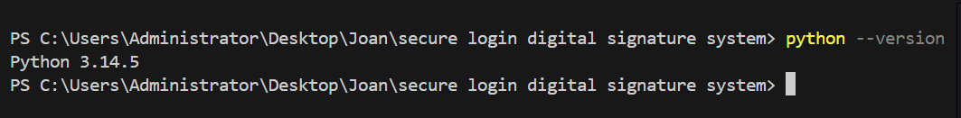

Fig 2: VS Code installed
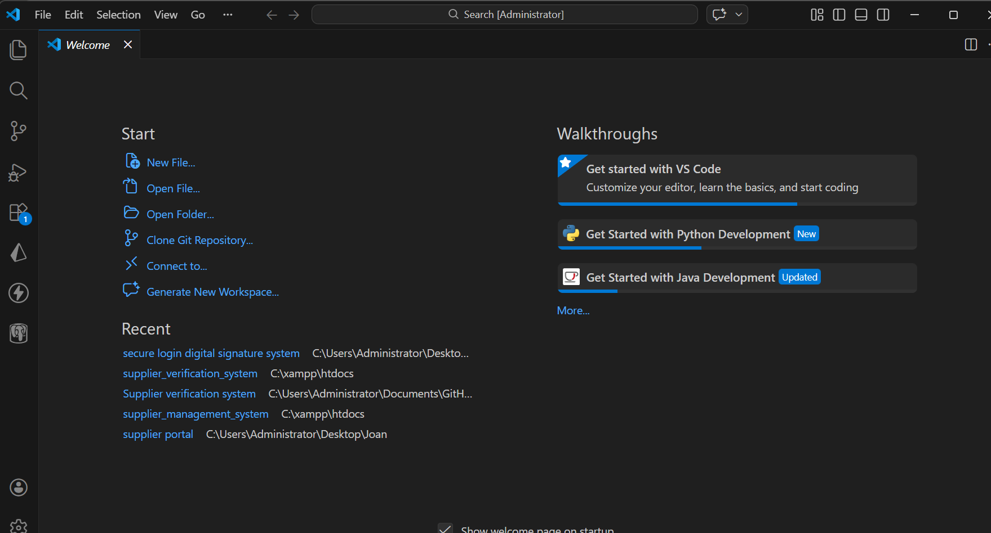

Fig 3: Cryptography libraries installed
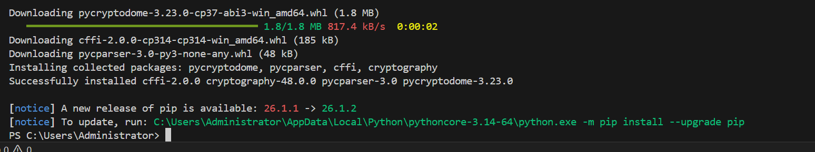

Fig 4: OpenSSL version command output
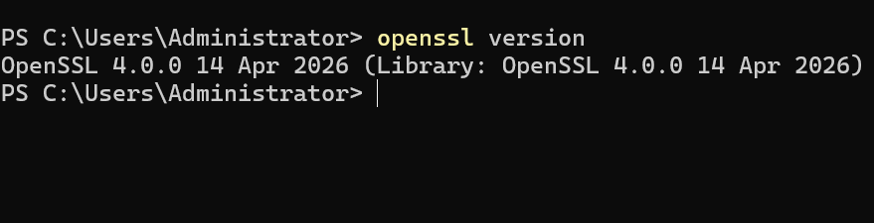

Fig 5: GitHub repository initialized; first commit shown on the repository page
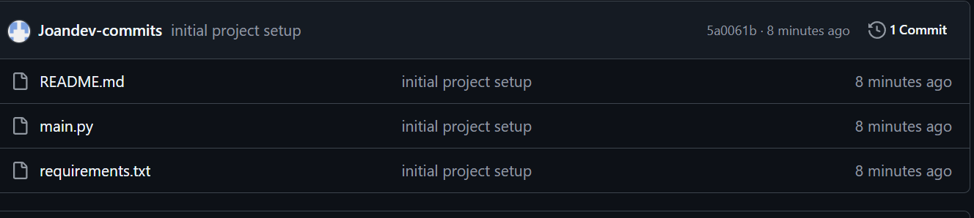

Student Reflection

I successfully installed Python, VS Code, OpenSSL and the cryptography library. I also created a GitHub repository for version control. The main challenge was ensuring all tools worked together correctly. The environment is now ready for implementing and testing cryptographic algorithms.

Week 2: Classical Cryptography and Cipher Design

Title
Implementation of Classical Encryption Algorithms

Required Evidence

Fig 1: Caesar Cipher Python script; encrypting SECURITY with shift 4
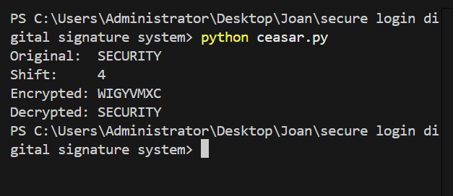
Fig 2: Vigenère Cipher Python script; encrypting NETWORK using keyword KEY
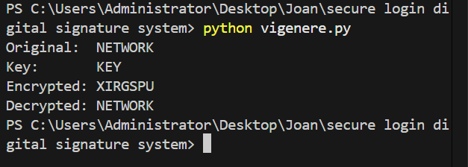

Fig 3: Encryption and decryption output 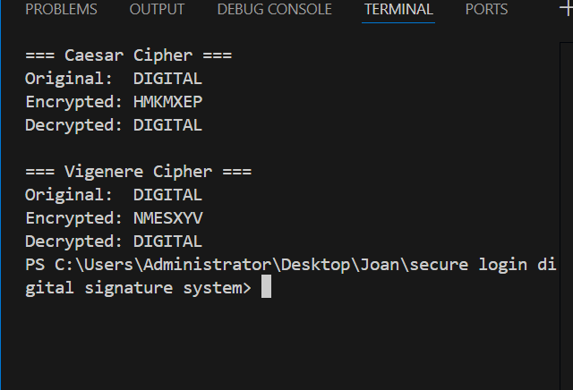

Fig 4: User input validation
Wrong input
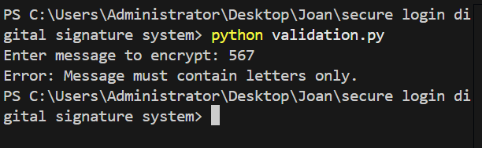
Correct input
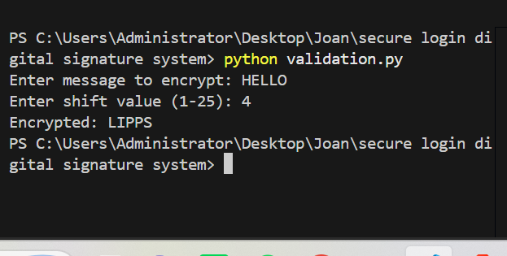

Fig 5: Cipher comparison test 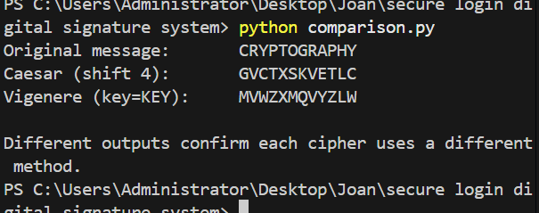

Student Reflection

I implemented Caesar and Vigenère ciphers and learned how encryption keys affect security. The Vigenère cipher provided stronger protection than Caesar because it uses multiple shifts. I also learned how encryption and decryption work and tested both algorithms successfully.

Week 3: Stream Ciphers and Randomness Testing

Title
Implementation of Stream Cipher Systems and Random Sequence Analysis

Required Evidence

Fig 1: Fig 1: LFSR generator output; binary sequence with period detection shown
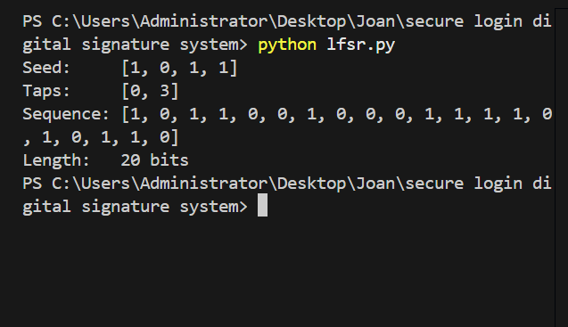

Fig 2: Pseudorandom sequence ; 100+ bits generated using Linear Congruential Generator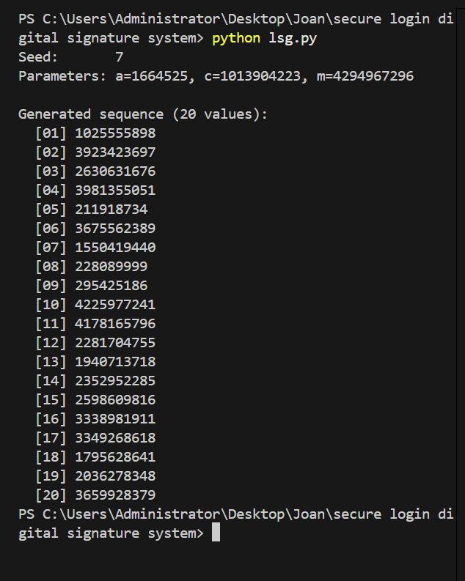

Fig 3: Statistical test results; Frequency Test and Runs Test output on generated sequence
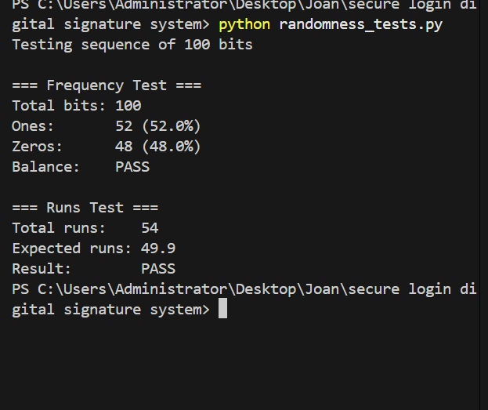

Fig 4: RC4 stream cipher simulation; message encrypted and decrypted successfully
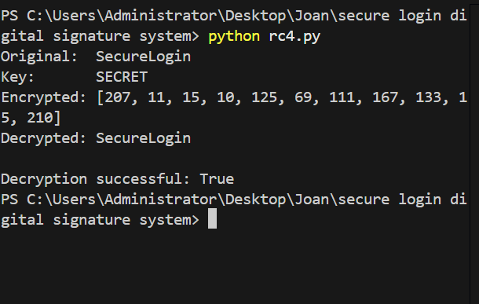

Fig 5: Encryption Performance Results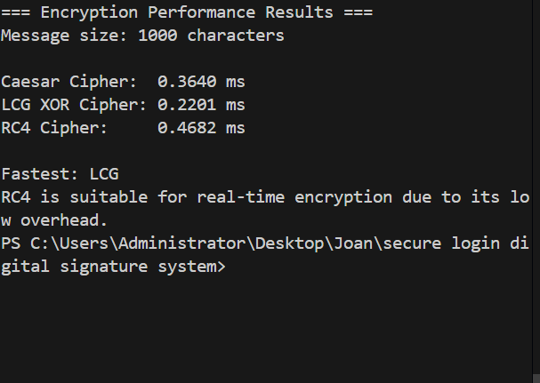

Student Reflection
I created pseudorandom generators and performed randomness testing. The results showed how weak randomness can make a cipher predictable. I also implemented an RC4 stream cipher and observed how the same keystream can encrypt and decrypt information securely.

Week 4: Block Cipher Design and AES

Title
Advanced Encryption Standard (AES) and Block Cipher Operations

Required Evidence

Fig 1: AES encryption Python script 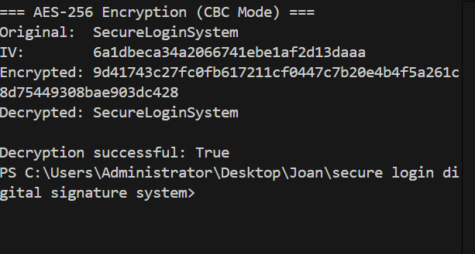

Fig 2: 256-bit symmetric key generation output undefined
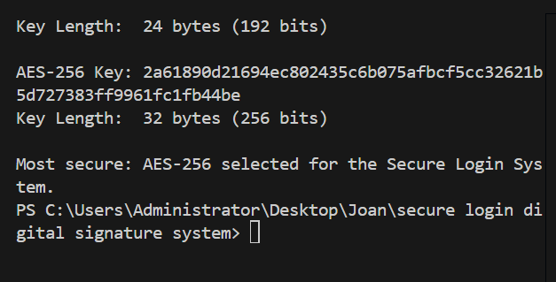

Fig 3: File encryption demonstration; plaintext input and encrypted output confirmed
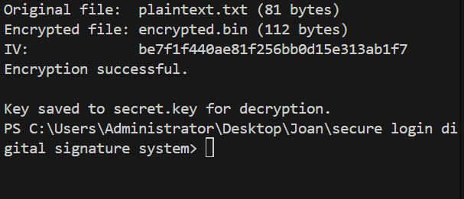

Fig 4: AES decryption results 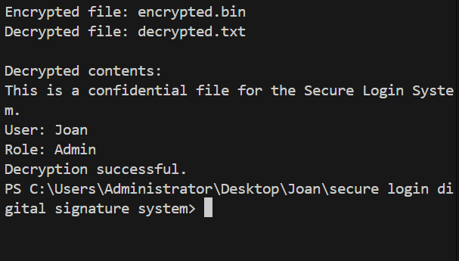
Fig 5: AES performance testing
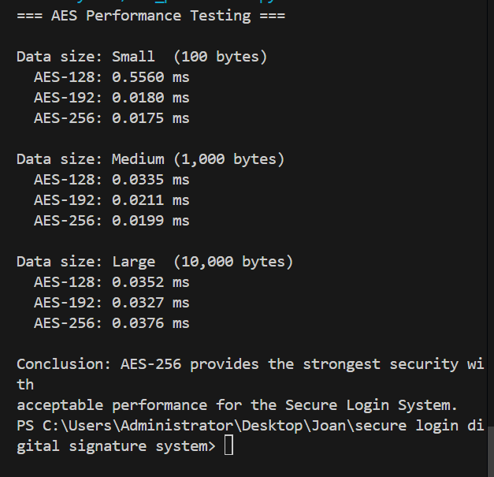

Student Reflection

This week I implemented AES encryption and decryption using Python. I learned how symmetric encryption protects information using the same secret key. I also carried out performance testing and observed how encryption time changes with larger amounts of data.

Week 5: Public Key Cryptography – RSA

Title
Implementation of RSA Encryption and Key Management

Required Evidence

Fig 1: Fig 1: RSA 2048-bit key pair generation; public and private keys printed to terminal
[ 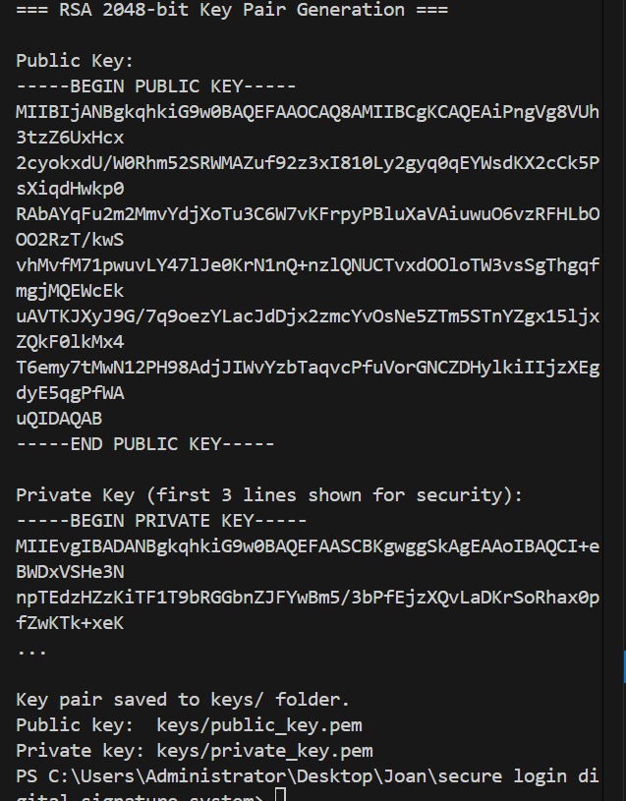

Fig 2: Fig 2: Public key encryption; message encrypted using the recipient's public key
[ 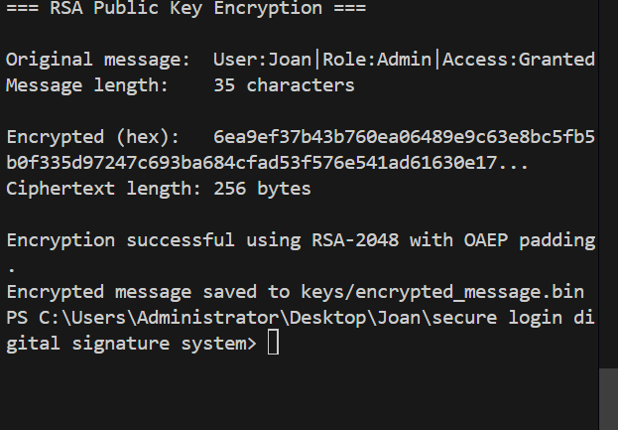

Fig 3: Fig 3: Private key decryption; original message successfully recovered
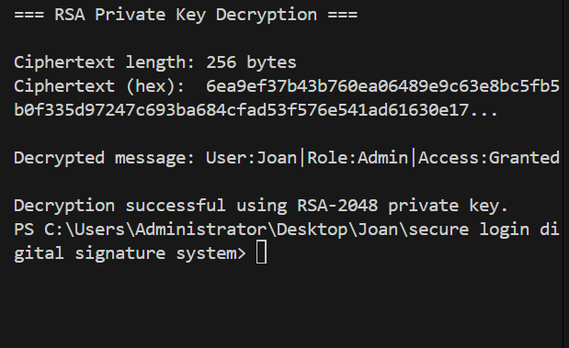

Fig 4: Secure message transmission simulation
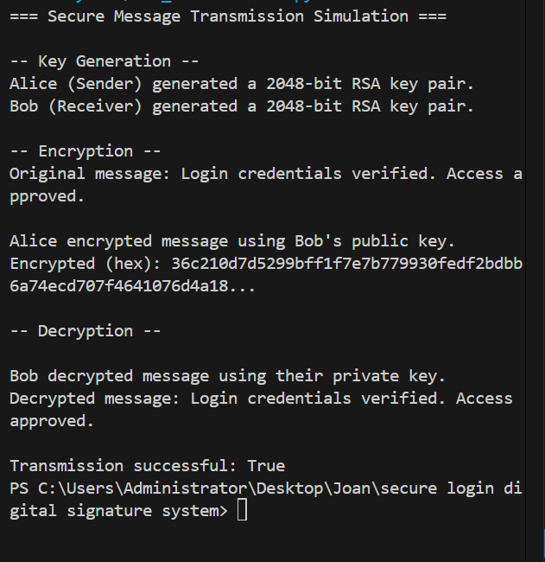

Fig 5: RSA testing and validation
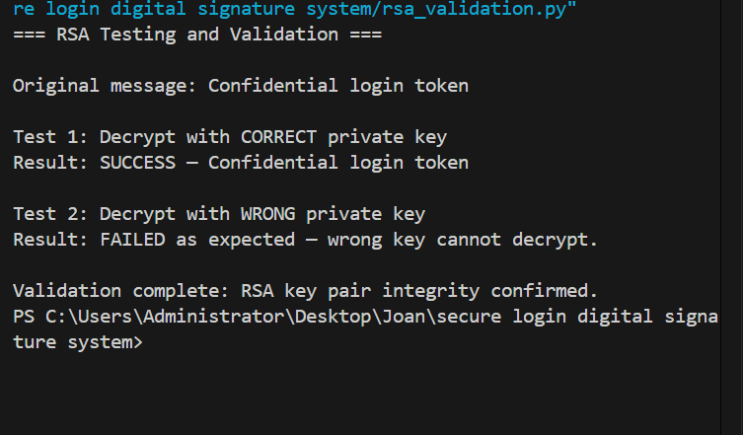

Student Reflection

This week I implemented RSA public key cryptography and generated key pairs for encryption and decryption. I learned the difference between symmetric and asymmetric encryption. Testing showed that only the correct private key can decrypt a message encrypted with the matching public key.

